**Lecture 26 – Sensory/Muscular/Skeletal System**

In this lecture, you will learn about various sensory receptors and anatomy and physiology of major sensory organs.

* Sensory receptors transduce stimulus energy and transmit signals to CNS.

1. ( ): Detection of a stimulus by sensory cells
2. ( ): Conversion of a stimulus to a change in membrane potential
3. ( ): Transmission of sensory information through nervous system via action potentials
4. ( ): Action potential reaching brain via sensory neurons

* Transduction of stimuli by sensory receptors is subject to ( ) and

( ).

* + Amplification: ( ) of a sensory signal during transduction via enzyme catalyzed reactions
  + Sensory adaption: ( ) in responsiveness upon continued stimulation. (Nociceptors do not adapt)
* There are five types of sensory receptors. Know what stimuli each type of receptors responds to.
  + Mechanoreceptors:
  + Electromagnetic receptors:
  + Thermoreceptors:
  + Chemoreceptors:
  + Nociceptors:
* Human skin has ( ), ( ), and ( ).
* Hearing is the transduction of pressure waves into nerve impulse. Thus, hearing uses what kind of receptors? ( ).
* Human ears are divided into three areas. Know basic structures and function of the human ear (Fig. 50.10).
  + Outer ear: collect and channel ( ).
  + Middle ear: transmit ( ).
  + Inner ear: ( ) in cochlea.
  + Transduction in the cochlea relies on ( ) and ( )
* Human ear is also an organ of balance and equilibrium (Fig. 50.13).
  + Mechanoreceptors in the inner ears detect equilibrium using ( ).
  + ( ) (three spatial planes): detect angular movement
  + ( ) and ( ): detect position and linear acceleration
* The sense of taste relies on ( ).
* ( ): taste receptor cells (epithelial cells) in tongue and mouth
  + Any region of tongue with taste buds can taste any of five types
  + Specific receptors for specific ( ).
  + 5 tastants are:
* The sense of smell relies on ( ).
  + Sensory cells are ( )
  + Humans have more than 1000 ( ) receptor genes
* Human eye is a complex organ. Know basic structure and function (Fig. 50.17)
  + Cornea
  + Iris
  + Lens
  + Aqueous humor
  + Vitreous humor
  + Retina
  + Optic nerve
* Focusing is achieved by the shape of ( ) controlled by ciliary muscles (Fig. 50.22)
  + The thicker the lens, the more sharply light is bent.
  + Retina contains layers of ( ) and ( ).
  + Retina contains two types of photoreceptors
    - ( ): sensitive to light, do not distinguish color
    - ( ): color vision (red, green, blue), contribute little to night vision
* Skeletal muscle is organized hierarchically (Fig. 50.26)
  + Skeletal muscle: attached to bones, striated
  + Hierarchical organization: muscle fiber, myofibril, thin filament ( ), thick filament ( )
  + ( ): basic contractile unit of muscle
* Muscle contraction is achieved by myosin-actin interaction
  + Sliding-filament model of muscle contraction

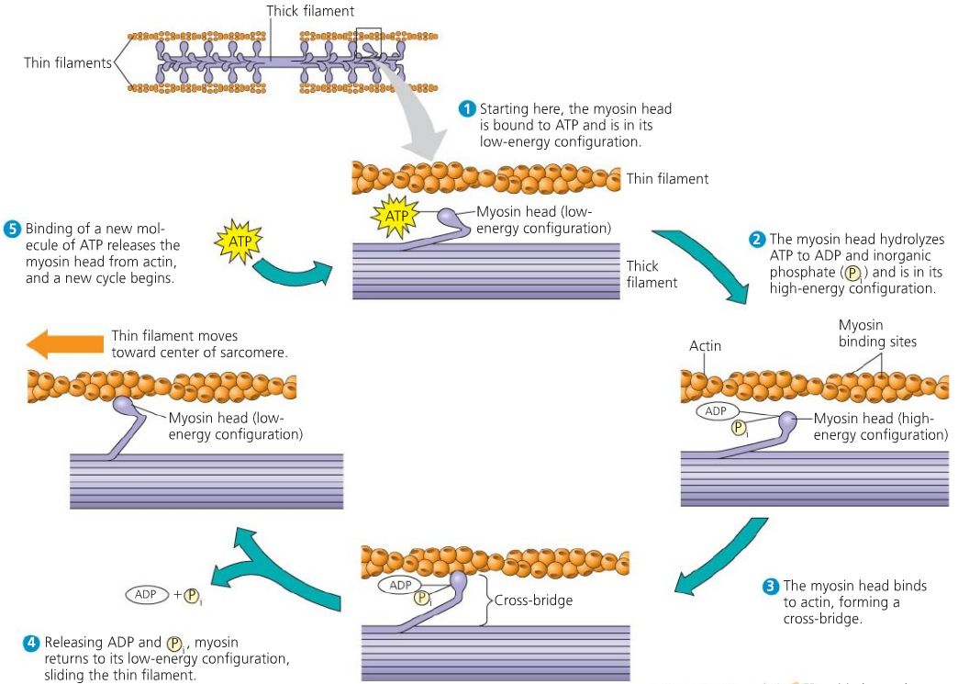

* Skeletal systems transform muscle contraction into locomotion
  + ( ) movement of muscles (Fig. 50.34)
  + A typical adult human skeleton consists of ( ) bones.